**Sanofi *i*Next Awards**

**2024-2025**

**Pre-proposal Application**

**General Information:**

Welcome to **Sanofi *i*Next Awards,** a groundbreaking initiative designed to bridge the innovation gap in immunoscience. This pitching competition aims to identify and incubate breakthrough ideas that push the boundaries of traditional R&D and venture investment frameworks. Selected “Moonshot” ideas will receive up to **$500,000** per project (inclusive of all costs) to fund an **18-month journey** of groundbreaking research, supported by Sanofi’s R&D expertise.

Led by the External Scientific Affairs (ESA) team of Vaccine R&D, in partnership with the Scientific Relations & Initiatives Pharma R&D, Sanofi iNext targets high-risk, high-potential innovations that fall outside the scope of existing programs. Together, we’re shaping the future of immunoscience by empowering bold ideas and fostering transformative breakthroughs.

Join us in driving bold innovations that redefine the future of immunoscience!

**Eligibility Criteria:**

* Startups that are from pre-seed (including academic laboratory/University spin offs) through Series A (less than $1M in revenue and less than $10M in investments).
* Must have a presence in the US or Canada.

**Instructions:**

* Pre-Proposal: This proposal template must be completed by project leaders and submitted through the [Submission Portal](https://app.smartsheet.com/b/form/4f36e146347544aab42d9b433523c757) as an attachment.
* Pre-Proposal Submission **Deadline: January 30th, 2025**

**Sanofi *i*Next Awards timeline**

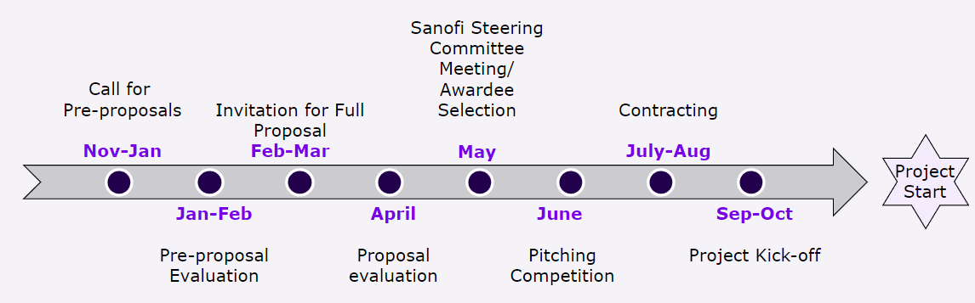

**Application:**

**Name of the applicant (Last, First)**: Click or tap here to enter text.

**Email address**: Click or tap here to enter text.

**Name and address of your company/institution:** ​Click or tap here to enter text.​

**Please check the exact scientific theme that your proposal best addresses in the options below:**

Vaccine approaches with an intent towards “cure” in the disease areas of dyslipidemia, and neuro-inflammation. Research proposals that have “root-cause” elimination strategies are preferred. Root-cause includes underlying infectious pathogen where applicable.

Tolerogenic approaches for the treatment or prevention of autoimmune and inflammatory diseases; proposals that leverage antigen with insight into relevant immune regulation pathways are preferred.

Please rename your pre-proposal file as follows: **COMPANY_2024-2025_Sanofi_iNextNA_pre-proposal_LAST NAME_FIRST NAME**. For "Company", use the name of your company. For academic lab-based spin-off, use the name of the University/Institution.

Please confirm (by checking the boxes below) that you have discussed the following line items and agree with your institution’s TTO and/or business unit as applicable:

If selected, my company/institution will collaborate with Sanofi during the 18-month iNext award

If selected, my company/institution agrees to allow Sanofi a 30-day review prior to submittal of any outputs of this funding award (i.e., publications, etc.)

If selected, third-party involvement will be pre-negotiated between my company/institution and the third party prior to signing the iNext award contract.

Receiving the iNext award is contingent on my company/institution completing the various contracting stages (research plan development, initial contract redlines, contract signing) within the Sanofi contracting timeline (see below timeline)

# **Project title**

Click or tap here to enter text.

**Section 1 – Briefly explain your platform/technology/idea** (350 characters maximum ≈ 1-4 lines, excluding spaces)

Click or tap here to enter text.  
  
**Section 2 – How do you plan to apply your idea/technology to prevent/treat one of the disease areas of interest presented here (Auto-immune, neuro-inflammation and dyslipidemia) (**<500 words)

Click or tap here to enter text.  
  
  
**Section 3 – Why is your approach considered as a “moon-shot” idea?** (<500 words)

Click or tap here to enter text.

**Section 4 – List out the top differentiation factors (up to 3) of your technology compared to other ideas that are pursued by players in the same disease/therapeutic area.**

Click or tap here to enter text.

**Section 5 – Have you had experiences applying this approach in other disease/therapeutic areas? If so, what was the outcome? If no prior application demonstrated, then say N/A.**

Click or tap here to enter text.

**Section 6 – References and team composition (Provide the expertise/background of the team that will do this work and why they are the right team to pursue this effort).**

Click or tap here to enter text.